Logically shifting the world >

WORKSHOP

Mr. AKSHAY RAMCHANDRA MUSMADE

for successfully participating in C WORKSHOP 2019 organized by Association of Computer Science and Engineering Students on

7th and 8th September.

Dr. B. F. Momin

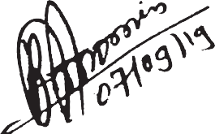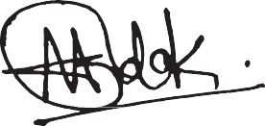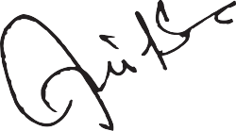

HOD CSE

Prof. A. R. Surve

Staff advisor

Utkarsh Kendre

President

Aniket Modak

Secretary